CSIT314 Software Development Methodologies - Group Project

Sprint 3 - US24: Search current IDPs
Interior Design Platform - Interior Designer
All diagrams were drawn in draw.io. Open "US24 Search current IDPs.drawio" in this folder to edit them - each diagram is its own page in that file. The exported images are in the "diagrams" folder.

Assumptions
- The system is the Interior Design Platform from the project specification. Sprint 3 covers the Interior Designer's current IDP stories (add, view, update, delete and search, US20 - US24) and the Customer's log in, IDP search, IDP view and log out stories (US30 - US32, US36).
- We follow B-C-E: the actor only talks to the boundary (page), the boundary only talks to the controller, and the controller works with the entity classes. There is one controller per use case.
- The boundary checks all the input (required fields, lengths, formats, e.g. not suspending your own profile) and trims spaces, then passes an entity object on. The controller just calls the entity and returns the result. The entity checks for duplicates and the database state (e.g. name already used, only Active rows are changed), then saves. In US24 the page trims the keyword (it can be empty), the controller just calls the entity, and the entity searches only the owner's Active Current IDPs in Active categories - it doesn't trim again.
- An IDP is an interior design project. A current IDP is one the designer is still working on (US20 - US24); a past IDP is a completed one (US25 onwards). Both are rows in the idp table with projectType Current or Past.
- Logged in as an interior designer (UC13) is the precondition. designerLoginRequired in app.py only sends someone with no session to /designer/login; the use case doesn't check the designer again (no InteriorDesignerLoginController).
- The keyword is matched as plain text (any case) against the title, the description and progress, the location and the category name. %, _, quotes and backslashes are ordinary characters. A keyword can match more than one field, but each IDP is listed once. Results are newest first, the same as US21.
- An empty (or only-spaces) keyword shows all of the designer's current IDPs - this is also what "Clear" does. Past and Suspended IDPs, other designers' IDPs and IDPs in a Suspended category are never shown.
- No match is a normal page with "No matching current IDPs found" and the keyword kept in the box. An empty search when the designer has no current IDPs shows "You have no current IDPs to display".
- Searching is read-only. "View" on a result opens the US21 preview, where Update (US22) and Delete (US23) are.

1. User story
Story ID | US24
User story | As an interior designer, I want to search my current IDPs so that I can find the IDP I need to manage.
Actor | Interior Designer
Priority | Medium
Story points (estimate) | 2
Acceptance criteria | 1. Given I am on my current IDPs, I can open "Search current IDPs".  2. Given I type a keyword and click "Search", then I see my Active Current IDPs whose title, description, location or category contains it (capitals don't matter), newest first, each with a "View" link.  3. Given the keyword is empty or I click "Clear", then I see all my current IDPs.  4. Given nothing matches, then I see "No matching current IDPs found" and my keyword stays in the box.  5. Given I have no current IDPs, then an empty search shows "You have no current IDPs to display".  6. Other designers' IDPs, Past and Suspended IDPs and IDPs in a Suspended category never appear, and searching changes nothing.
Tasks | T24.1 Write the use case description and draw the use case diagram  T24.2 Draw the B-C-E class diagram and the sequence diagram  T24.3 Draw the wireframes for the search form, matching results, no match and no current IDPs  T24.4 Write the unit tests first (TDD) for IDP, SearchCurrentIDPController and SearchCurrentIDPPage  T24.5 Code IDP.searchCurrentIDPs(designerId, keyword) (owner, Current, Active, Active category)  T24.6 Code SearchCurrentIDPController (just calls the entity)  T24.7 Code SearchCurrentIDPPage (trims the keyword), the search template and the link on Current IDPs  T24.8 Run the test cases, fix bugs and push to the repo so the CI pipeline runs the unit tests

2. Use case diagram
The user story becomes one use case, UC24 Search current IDPs. The Interior Designer is the only actor. Viewing a result continues in UC21.
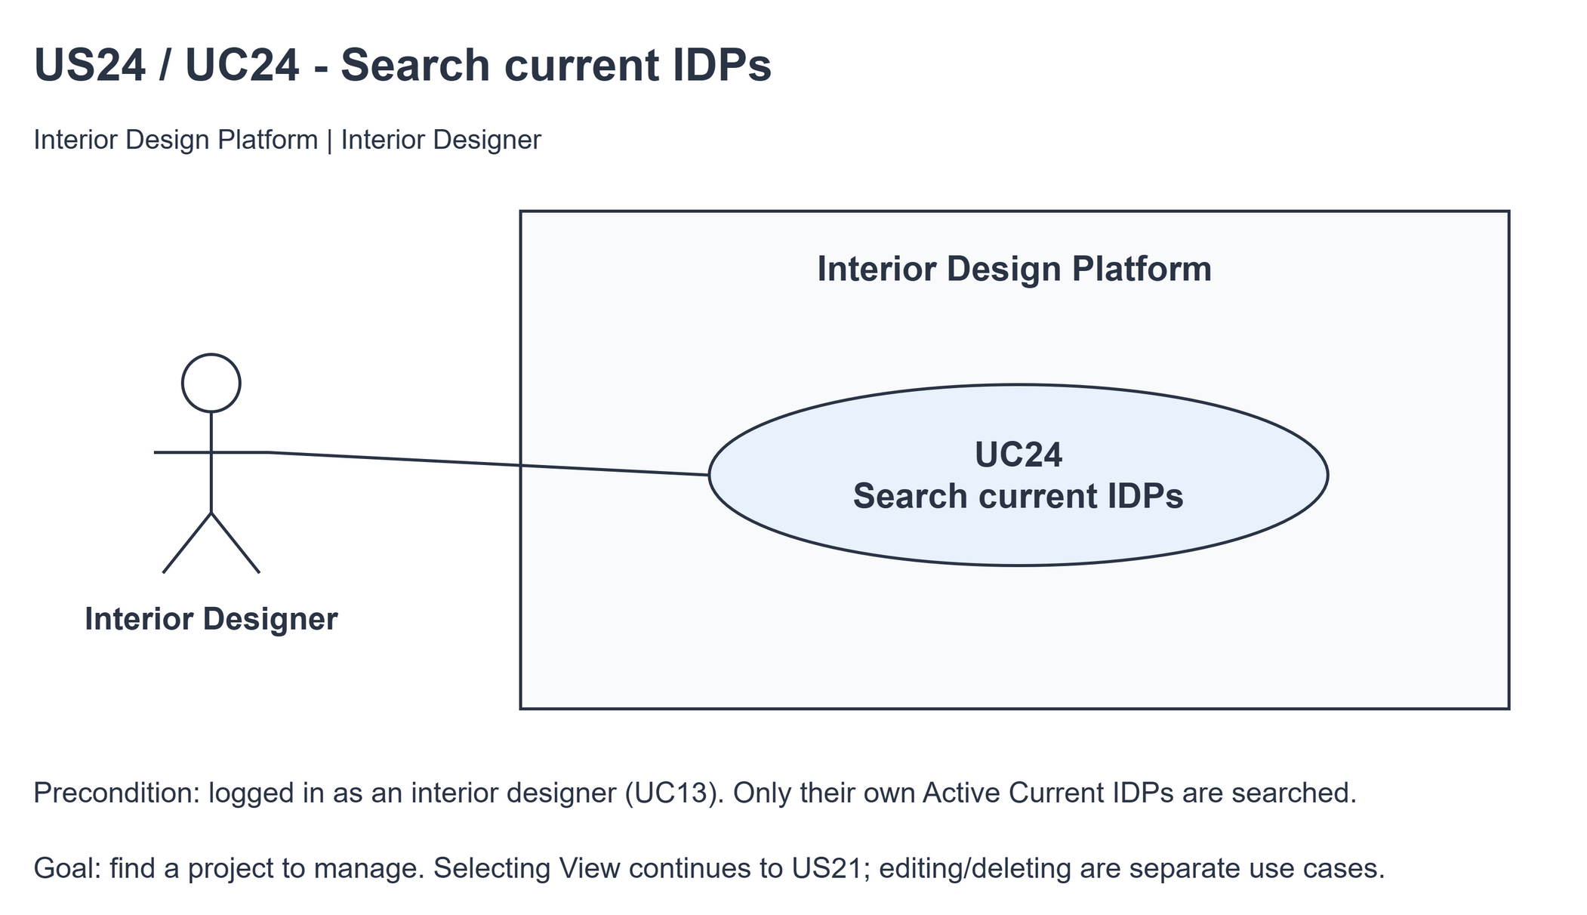
Figure 1: Use case diagram for US24 Search current IDPs

3. Use case description
Use case | UC24 Search current IDPs
Actor | Interior Designer
Brief description | The Interior Designer searches their own current IDPs to find the one they need to manage.
User story | US24: As an interior designer, I want to search my current IDPs so that I can find the IDP I need to manage.
Preconditions | The Interior Designer is logged in (UC13). designerLoginRequired in app.py only sends someone with no session to /designer/login.
Trigger | The Interior Designer clicks "Search current IDPs" on Current IDPs, or submits the search form.
Basic flow | 1. The Interior Designer types a keyword and clicks "Search" (opening the page is an empty search).  2. The system trims the keyword.  3. The system finds the designer's Active Current IDPs in Active categories whose title, description, location or category name contains the keyword, newest first.  4. The system shows the matching IDPs, how many were found and the keyword.  5. The Interior Designer clicks "View" on a result and the preview opens (UC21).
Alternative flows | 1a. The keyword is empty or the Interior Designer clicks "Clear": the system shows all of the designer's current IDPs.  3a. Nothing matches: the system shows "No matching current IDPs found" and keeps the keyword. Back to step 1.  3b. The keyword is empty and the designer has no current IDPs: the system shows "You have no current IDPs to display".  5a. The IDP was deleted or hidden after the search: UC21 shows "Current IDP not found" (HTTP 404).
Postconditions | Nothing is changed. Another designer's IDPs are never shown.

4. Wireframes
The wireframes were drawn in draw.io. They are low-fidelity: they show the layout and the flow, not the final colours.

4a - Search form and all current IDPs
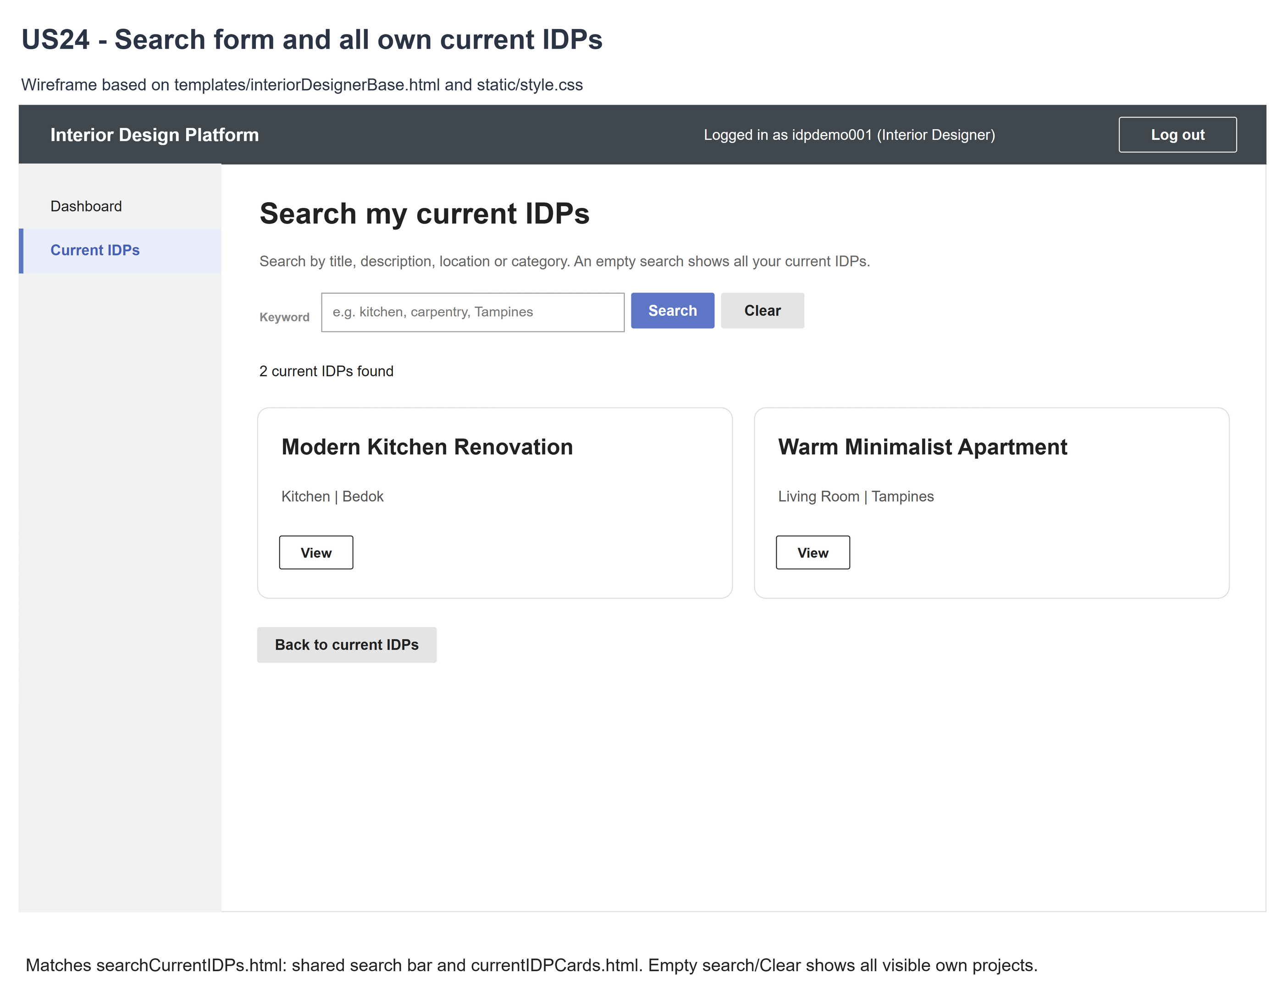
Figure 2: Wireframe 4a - Search form (US24)

4b - Matching results
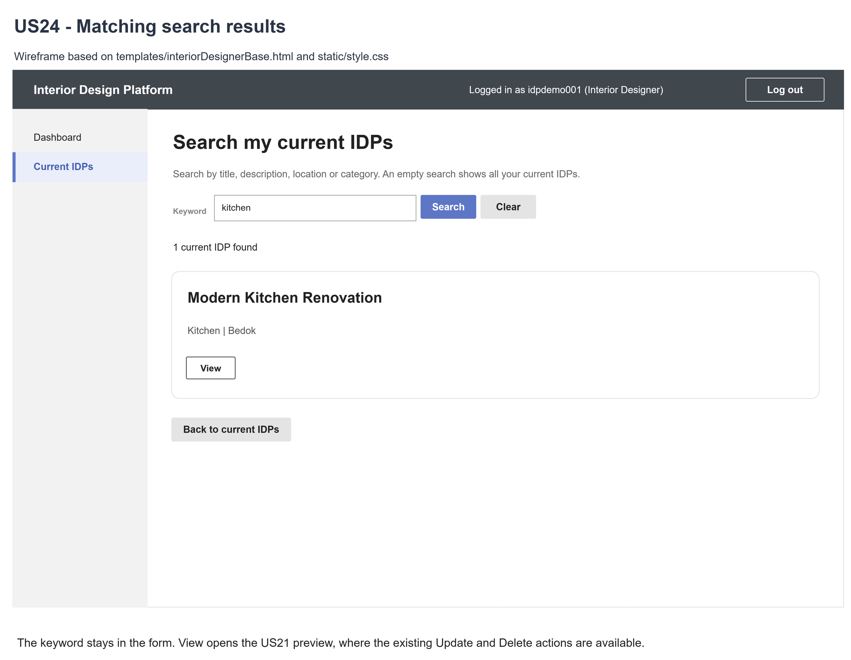
Figure 3: Wireframe 4b - Matching results (US24)

4c - No matching results
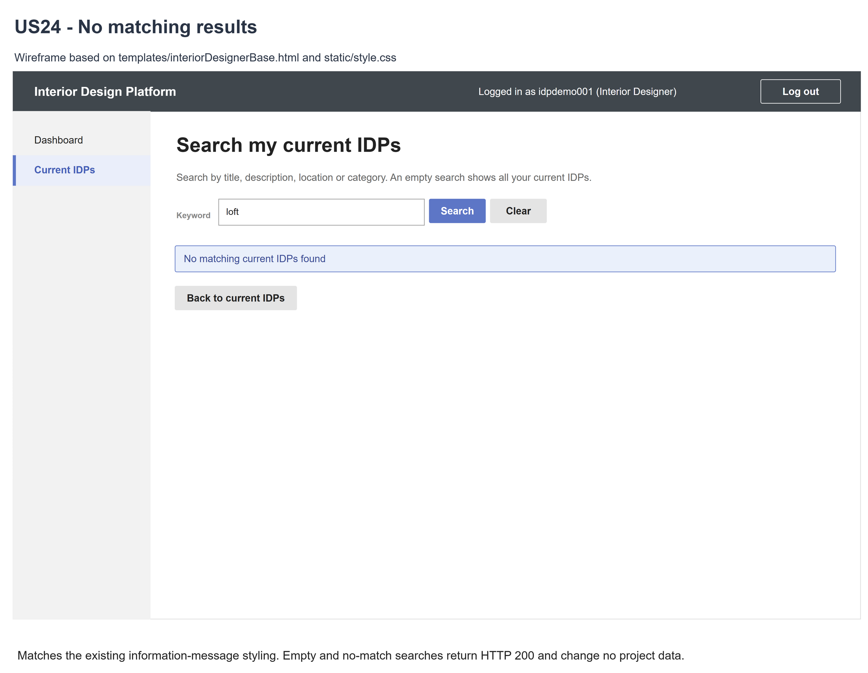
Figure 4: Wireframe 4c - No matching results (US24)

4d - No current IDPs
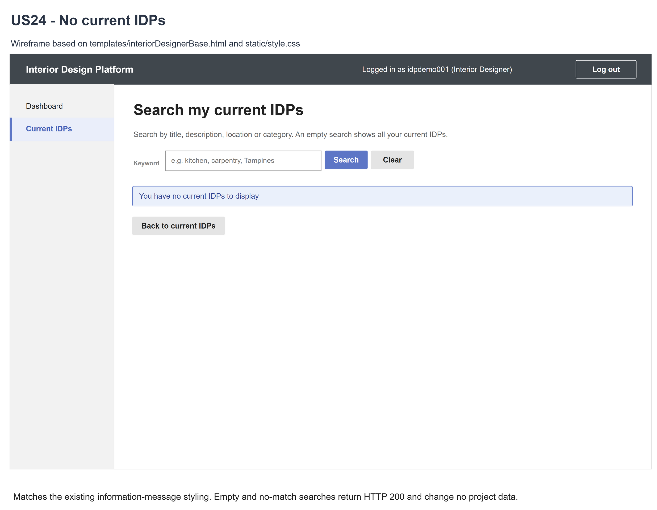
Figure 5: Wireframe 4d - No current IDPs (US24)

5. B-C-E class diagram
The solid line means the boundary calls the controller. The dashed line means the controller uses the entity. Only the operations needed for this use case are shown. categoryName is joined for display, it isn't a new column.
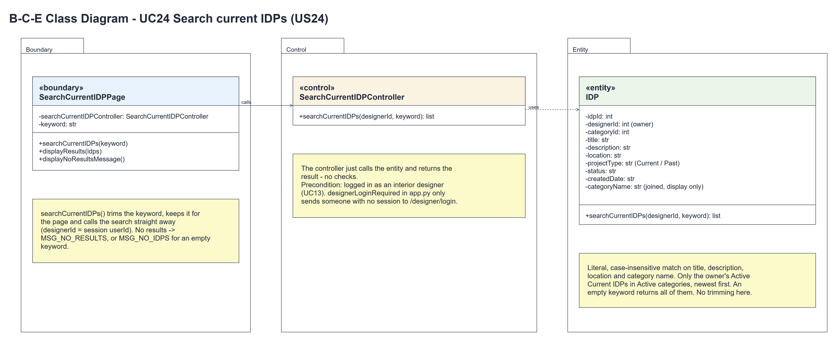
Figure 6: B-C-E class diagram for US24 Search current IDPs
Layer | Class | What it does
Boundary | SearchCurrentIDPPage | The search page. searchCurrentIDPs(keyword) trims the keyword, keeps it for the page, calls the controller with designerId = session userId and shows displayResults(idps) or displayNoResultsMessage() ("No matching current IDPs found", or "You have no current IDPs to display" for an empty keyword).
Control | SearchCurrentIDPController | Controller for UC24. searchCurrentIDPs(designerId, keyword) just calls the entity and returns the result - no checks and no trimming.
Entity | IDP | The only entity. searchCurrentIDPs(designerId, keyword) matches the keyword (any case, as plain text) against the title, description, location and category name of the owner's Active Current IDPs in Active categories, newest first. An empty keyword returns all of them.

6. Sequence diagram
The sequence diagram follows UC24. The page trims the keyword and calls searchCurrentIDPs(designerId, keyword) straight away (steps 1-2); the controller makes one call to IDP.searchCurrentIDPs() (step 3). The alt shows the matching IDPs (step 4) or the no-results message (3a, 3b). Viewing a result is UC21.
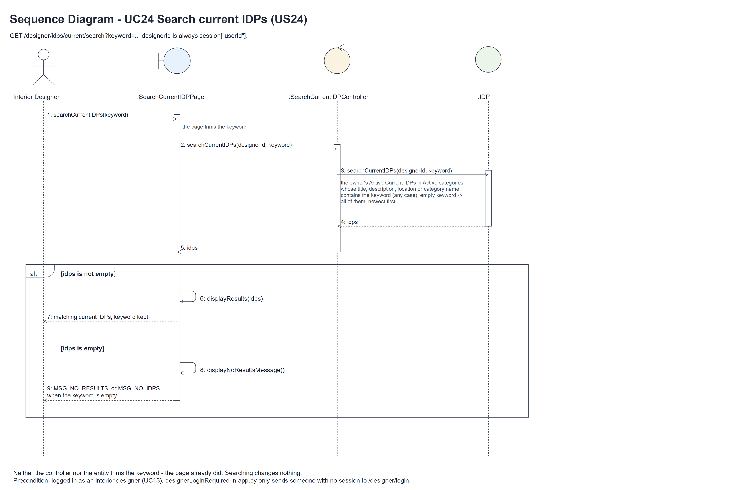
Figure 7: Sequence diagram for UC24 Search current IDPs

7. Test cases
Test data used below (the same as tests/test_us24_searchCurrentIDPs.py, which reuses the US22 test data): designer accounts update22 (A) and other22 (B) / Design@123, made with UC8. IDP categories Living Room and Kitchen (Active) and Hidden (Suspended). A owns "Own Current Project" (Living Room, "Initial progress", Tampines) and "Kitchen 100%_Plan" (Kitchen, "Straße carpentry O'Neil 客厅 Café C:\plans", Bedok), plus a Past IDP, a Suspended IDP and an IDP in Hidden. B owns "Other Designer Project".

7a. System test cases (black box)
Equivalence partitioning and boundary value analysis were used to pick the test data. Fill in "Actual result" and "Pass/Fail" after running each test.
Test ID | Scenario | Prerequisites | Test steps | Test data | Expected result | Actual result | Pass / Fail
TC24.1 | Title search | Logged in as A. | 1. Type part of a title / 2. Click "Search" | Plan | Kitchen 100%_Plan; the keyword stays in the box.
TC24.2 | Progress search | Logged in as A. | 1. Search a word from the description | carpentry | Kitchen 100%_Plan.
TC24.3 | Location and category search | Logged in as A. | 1. Search a location / 2. Search a category | Bedok; Living Room | The matching IDP for each.
TC24.4 | Capitals and spaces | Logged in as A. | 1. Search with capitals and spaces around | " KITCHEN " | The page trims the keyword; Kitchen 100%_Plan is found.
TC24.5 | Clear / empty | Logged in as A. | 1. Search "Plan" / 2. Click "Clear" (or search spaces) | Empty; spaces | All of A's current IDPs, newest first.
TC24.6 | No match | Logged in as A. | 1. Search a word that isn't there | unmatched-zebra | "No matching current IDPs found" (HTTP 200); the keyword is kept.
TC24.7 | No current IDPs | A has no current IDPs. | 1. Open the search page | Empty keyword | "You have no current IDPs to display" (HTTP 200).
TC24.8 | Only own visible IDPs | Logged in as A. | 1. Search a word in every IDP | Project | Only A's Active Current IDPs in Active categories.
TC24.9 | Not logged in / profile changed | Not logged in; or logged in as A and then A's profile is suspended (UC6). | 1. Open the search page | - | Not logged in: sent to the designer login page. Profile suspended: the search still works for this session - being logged in is the precondition (UC13), so it isn't checked again. | Not logged in: sent to /designer/login. Profile suspended: the search still showed Kitchen 100%_Plan (HTTP 200). | Pass
TC24.10 | Special characters | Logged in as A. | 1. Search each character | %, _, ', \ | Matched as plain characters, not wildcards.
TC24.11 | Results stay current | Logged in as A. | 1. View a result / 2. Update or delete it (UC22, UC23) / 3. Search again | Changed or deleted IDP | The new values are found; the deleted IDP is gone and its old View link gives HTTP 404.
TC24.12 | Read-only, escaped | Logged in as A. | 1. Search; compare the database / 2. Search script text | <script> | Nothing changes; the text is shown escaped.

7b. Unit test cases (for TDD)
These are written before the code (test-driven development) and run automatically in the CI pipeline. They cover normal inputs, abnormal inputs and boundary values. Each one matches a test function in tests/test_us24_searchCurrentIDPs.py (UT24.1 is test_ut24_1_...). "Pass" is from the pytest run on 10 November 2026.
Test ID | Class and method | Input / setup | Expected output | Type | Pass / Fail
UT24.1 | IDP.searchCurrentIDPs() | Part of a title | A's matching IDP | Normal | Pass
UT24.2 | IDP.searchCurrentIDPs() | Part of a description | A's matching IDP | Normal | Pass
UT24.3 | IDP.searchCurrentIDPs() | Part of a location | A's matching IDP | Normal | Pass
UT24.4 | IDP.searchCurrentIDPs() | Part of a category name | A's matching IDP | Normal | Pass
UT24.5 | IDP.searchCurrentIDPs() | KITCHEN, kItChEn, STRASSE, straße, CAFÉ, 客厅 | Matched whatever the capitals (Unicode case folding) | Normal | Pass
UT24.6 | SearchCurrentIDPPage.searchCurrentIDPs() | Keyword "", missing, " " or tabs (the page trims them to "") | All of A's current IDPs, newest first | Boundary | Pass
UT24.7 | SearchCurrentIDPPage.searchCurrentIDPs() | " Own Current " | The page trims it; the entity gets "Own Current" and finds A's IDP | Normal | Pass
UT24.8 | IDP.searchCurrentIDPs() | Two matches | Newest idpId first | Normal | Pass
UT24.9 | IDP.searchCurrentIDPs() | unmatched-zebra | [] | Abnormal | Pass
UT24.10 | IDP.searchCurrentIDPs() | A word in A's and B's IDPs | Only A's IDP | Abnormal | Pass
UT24.11 | IDP.searchCurrentIDPs() | B's IDP; A's Past, Suspended, Hidden IDPs | Left out | Abnormal | Pass
UT24.12 | IDP.searchCurrentIDPs() | %, _, ', \ | Matched as plain characters only | Boundary | Pass
UT24.13 | IDP.searchCurrentIDPs() | SQL-like keyword | []; the database is unchanged | Abnormal | Pass
UT24.14 | IDP.searchCurrentIDPs() | A matching saved IDP | The right fields and joined categoryName | Normal | Pass
UT24.15 | IDP.searchCurrentIDPs() | A word in the title and the category | The IDP once, no duplicates | Normal | Pass
UT24.16 | SearchCurrentIDPController | Look at the class | Only searchCurrentIDPs() - no access-check method and no login controller | Normal | Pass
UT24.17 | SearchCurrentIDPController.searchCurrentIDPs() | InteriorDesignerLoginController would return None | No exception - one entity call, its result returned | Abnormal | Pass
UT24.18 | SearchCurrentIDPController.searchCurrentIDPs() | A, " Kitchen " | Calls IDP.searchCurrentIDPs(A, " Kitchen ") - the controller doesn't trim | Normal | Pass
UT24.19 | designerLoginRequired (app.py) | GET the search page, not logged in | Redirects to /designer/login | Abnormal | Pass
UT24.20 | Search page | admin01 logged in on /login, cust001 on /customer/login | The role isn't checked again (precondition UC13): HTTP 200 with "You have no current IDPs to display" (they own no IDPs); never forbidden | Abnormal | Pass
UT24.21 | SearchCurrentIDPPage.displayResults() | Keyword Kitchen | One card, "1 current IDP found", the keyword kept, Search and Clear | Normal | Pass
UT24.22 | SearchCurrentIDPPage.displayNoResultsMessage() | unmatched-zebra | "No matching current IDPs found" (HTTP 200); the keyword kept | Abnormal | Pass
UT24.23 | Clear | Search kitchen, then the page without a keyword | Both of A's IDPs | Normal | Pass
UT24.24 | Empty search | A has no IDPs | "You have no current IDPs to display" (HTTP 200) | Boundary | Pass
UT24.25 | Search page | designerId / userId of B in the URL | Only A's IDPs (session owner) | Abnormal | Pass
UT24.26 | Search page | Several searches; POST, PUT, PATCH, DELETE | The database is unchanged; the other methods give 405 | Normal | Pass
UT24.27 | Links and View | Current IDPs page; a result's View; then suspend that IDP | Search link and View link shown; the old View gives HTTP 404 | Normal | Pass
UT24.28 | Search after logging in | A's account / profile / permission changed after logging in | Not checked again: the search still gives HTTP 200 for this session | Abnormal | Pass
UT24.29 | Search after UC22 and UC23 | Update the title with updateCurrentIDP(idp), search; delete with deleteCurrentIDP(designerId, idpId), search | The new title is found; the deleted IDP is not | Normal | Pass
UT24.30 | Search page | <script> as keyword and saved title | Shown escaped, not run | Abnormal | Pass
UT24.31 | SearchCurrentIDPPage.searchCurrentIDPs() | InteriorDesignerLoginController would deny A | It isn't called: the page calls searchCurrentIDPs(A, keyword) straight away and shows HTTP 200 | Abnormal | Pass
UT24.32 | Search page | A 5000-character keyword | HTTP 200, no match, nothing changes | Boundary | Pass

